Going In The Spirit to The Suffering 2
January 4th, 2021

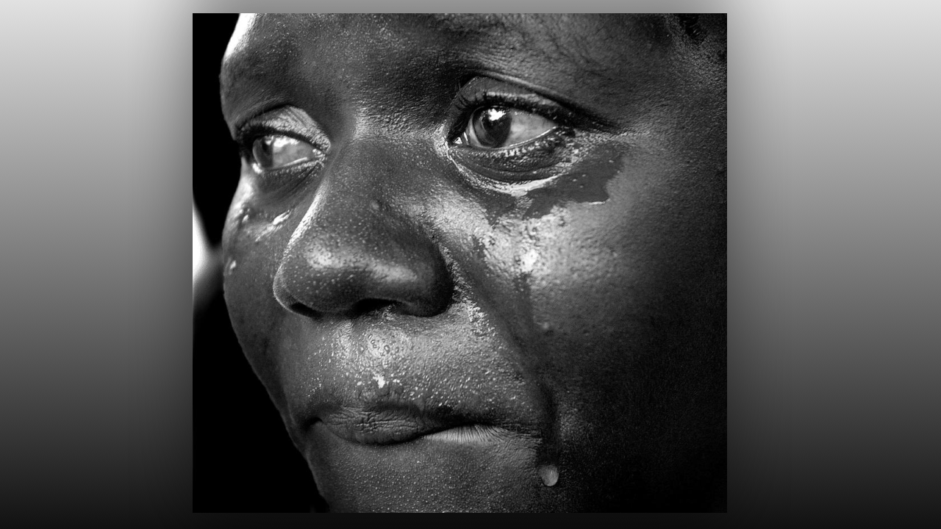
Lord please help us to rivet our gaze on You as we are called into new territory to minister. Amen.

Our Lady began by pointing out a brother’s prayer as we began our group intercession. She said, “I love his sincerity. How beautiful is the soul that prays in truth from the heart. My dear ones, please when you come to pray and ask for my prayers, really be aware of what you are asking. This is a holy moment between you and I, you are actually speaking to me and I am listening with all my heart. We have a real relationship, truly God has given me a mother’s heart for all of humanity, and your sincere conversation with me, affirms that truth.

Mother and son, Mother and daughter, how beautiful is the loving relationship between them. There is no mystery as to how I can be present to you and present to those in China at the same time. Grace stretches what we think of as reality. In actuality grace is presenting the reality of life in the spirit rather than this compact and limiting dimension you are so accustomed to functioning in.

Therefore, it is no mystery that I can be in several places at once. In Heaven, depending on your state, for some there are no limitations of space, time or intellect. Why is this? Because our good Lord does not want us to miss out on any opportunity to minister to those in need. Some call this the fifth dimension, I call it God’s endless mercy and provision that all may be satisfied with the sweet, nourishing drink of eternal life without limit. It is a remarkable freedom He bestows upon those who are called out to minister and comfort others.

In the recent exercises given to you by Bishop Ezekiel, you were taken, by the spirit to those you wanted to comfort. I will tell you this now, that is the noblest thing you can do next to worshipping God, and because of this, He has allowed matter, energy, space and time to serve the needs of the suffering. Is this not an unheard-of gift? That you should be like God, able to be in many places simultaneously? All that is required is love and compassion with a strong desire to comfort others. You see all that He does is because of love, love and love again.

Now you are coming into an era where extraordinary gifts are being passed out to make salvation available to the most remote souls. Your sweet sister, St. Mary Agreda, had this gift and ministered to the Native Americans right here on this very spot you have been given. Over a century ago, she sanctified this place with a prayer that it would become a holy land for the local tribes. What an outrageous request!

But her faith was sufficient that she was able to do that very thing and God heard her prayer. What motivated her? Love for the Native American people and her desire to see the faith grow in them. Everything, when you follow it back to its very roots is grounded in LOVE.

Now your hearts are becoming sensitive to the needs of a people far removed, living in terror and unprecedented loss. Because you care, you are led to them in order to be the hands and feet of Christ and minister spiritual healing to them as well as an occasional physical healing from the atrocities committed against your God. Yes, these are atrocities committed against mankind who is made in God’s image and likeness and who came forth from His Heart.

When you love them, you become like Him and He is able to be anywhere, anytime, in multiple places, and so He shares this gift with you so that you can do the works He does. As long as you keep your hearts riveted on the right motive, you will grow in the ability to reach more souls, without limit. Clutch this to your heart, bury it there mixed with faith and embrace the glorious gifts He is offering you.

